User Evaluation
In this document we summarized the app evaluation from external users, highlighting their general opinion and what they like and dislike of the app, also inserting personal opinion on how to improve it.

The evaluation is subdivided into two parts, the first part is about what they can expect from the app, the second part is about the evaluation of the app itself

Evaluation Method
The evaluation was structured in two distinct phases to capture both initial expectations and actual user experience:
- Pre-use Questionnaire: Focused on user expectations regarding applications for visiting and exploring Points of Interest (POIs) and what would motivate continued use.
- Post-use Questionnaire: Focused on the evaluation of the app itself after direct interaction, highlighting likes, dislikes, and general opinions.

User Profile
- Age Range: All participants in the evaluation were between 17 and 24 years old.
- Target Group: Young adults interested in cultural exploration and digital tools for discovering new locations.
- Criteria: The age of participants is not higher than the young demographic range, but we considered that the feedback we collected identified features and issues in a generalistic manner, deeming an expansion of age in surveys not necessary. Difficulties in testing activities would also arise due to the less technical knowledge owned by older people. Finally, due to technical limitations of the application itself needing a gps and a POI to unlock and placing by hand every POI near the tester, complete and easy testing of the app would not have been practical.

Result from questionnaire before using the app
In this questionnaire we asked about:

- Whether an application about visiting, exploring, learn from Points of Interest, should tempt you in using it more
- If the user knows what’s a gamified application
- Whether the user has already tried similar applications before and write what they lack for them to feel complete (multiple choice):
  - A cultural learning part
  - The feature of recommending places based on their interests
  - A connection between users
  - A “gamey” part to make it less boring
  - Other (open answer)
- The user’s opinion about what application they would expect
- Their interest in having expendable value in points to buy elements in the application
- How much time the user is willing to allocate to travel from one Point of Interest to another
- Their interest in getting recommendations about dining areas during a visit in a city

The results of the questionnaire state, in order from the previous list:
- Everyone agrees about the application tempting them to use it more
- 60% of users (more than we expected) know what a gamified application is, 20% of them heard about it.
- Results for already tried applications are homogenous except for the “connection” answer, with one who’s not interested with exploring cities
- Expectations include:
  - Google Maps but specialized in giving definite itineraries based on POIs/interests
  - Being interactive and engaging
  - A list of POIs to visit
  - Description and directions of POIs
  - Cosmetic rewards for reaching a POI
  - Social aspect to show owned cosmetics and what POIs a user has explored
- Majority of people are interested in earning and spending points in application content (20%-0-0-40%-40% votes from least to most interested)
- 60% of users want to spend around 30 minutes traveling from one point to another, 20% only 15 minutes, with an opinion of “Time doesn’t matter if the POI interests me and the route is optimal to not go back and forth”
- 20%-0-0-40%-40% votes for being interested in recommendations for dining areas during a visit, meaning a majority wish for it.

Result from questionnaire after using the app
In this questionnaire we asked about:
- How much does the application differ from expectations
- If the application encouraged the user to continue to use it
- Usability of the interface and pros and cons
- The user experience in gamification elements
- Negative impressions about the app
- Positive impressions about the app
  - Also if we fix the application the user will use it
- We also asked if they like other improvements that we can have done to the map

The results of the questionnaire state, in order from the previous list:

How much does the application differ from your expectations?
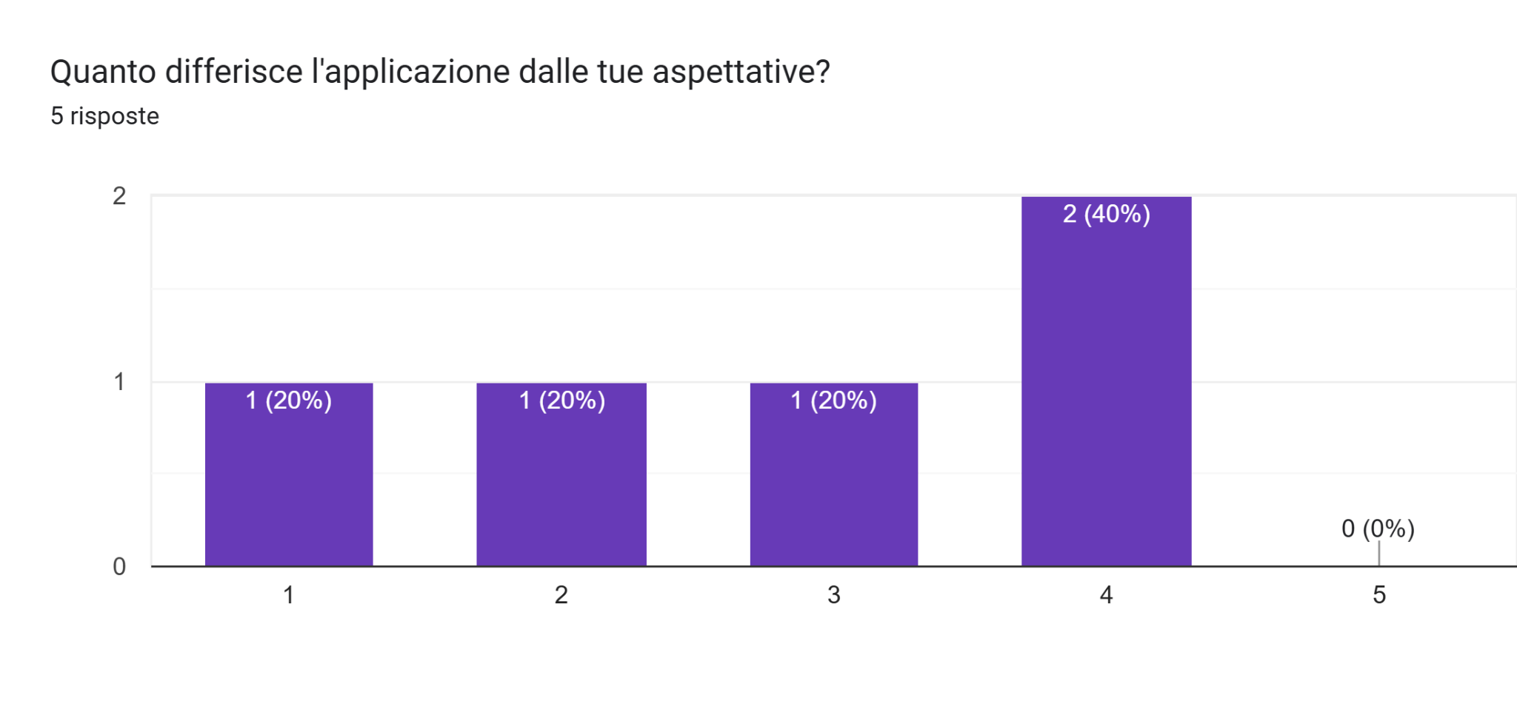
Did the application you tried encourage you to continue using it?
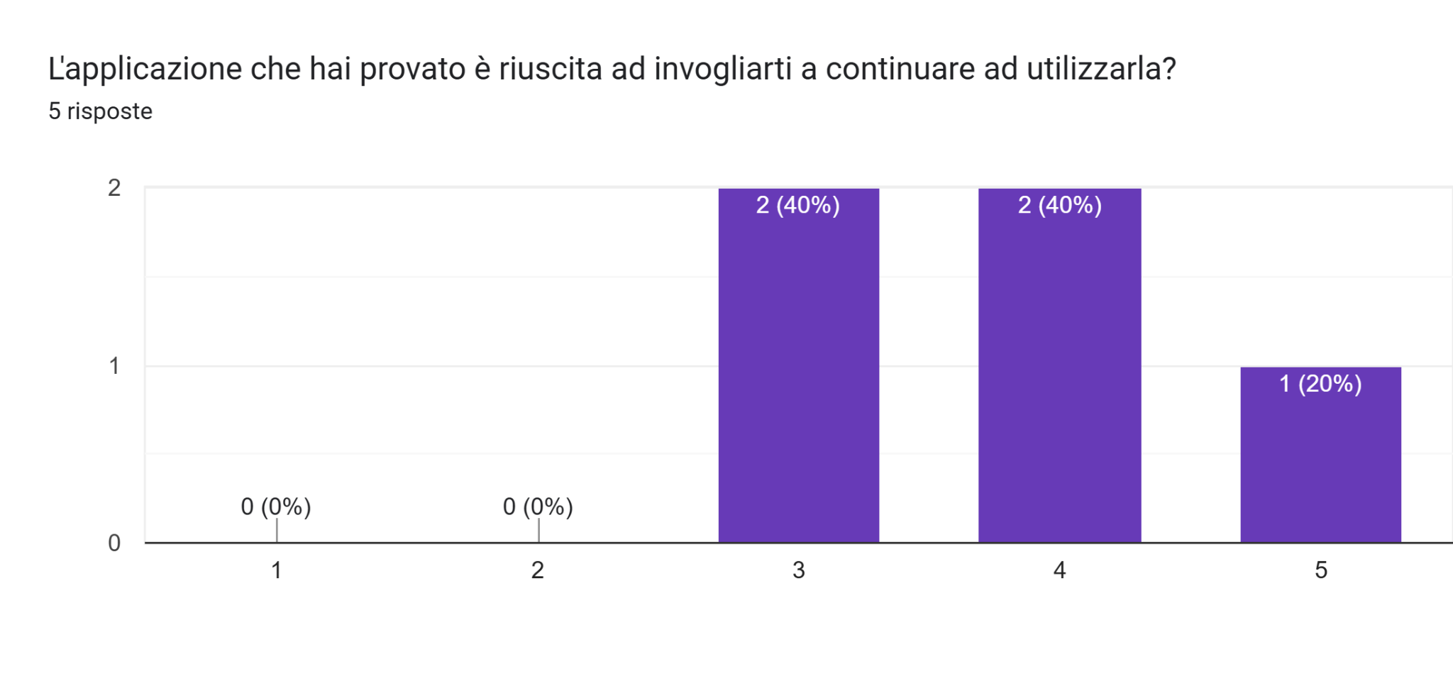

How intuitive is the interface?
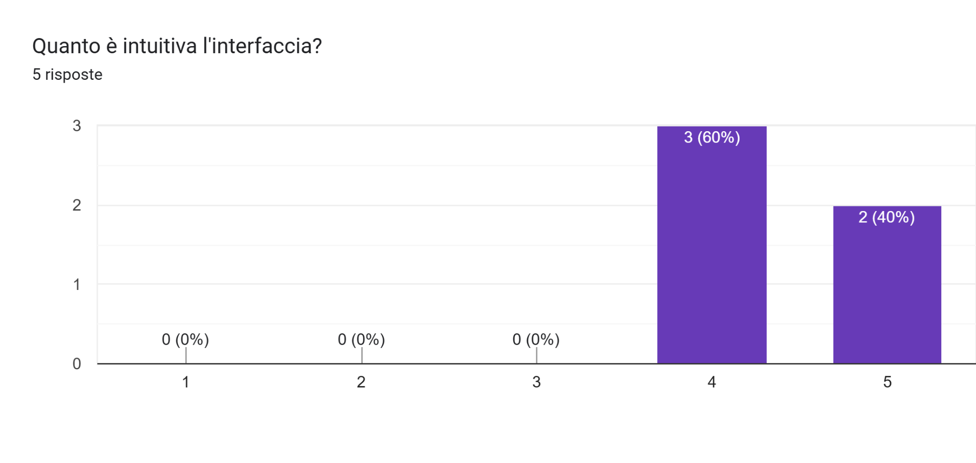
Is there anything you would change about the interface? (open question with also pre defined options )
- UI Quiz (Questions and Final Feedback) It doesn't feel like you've completed a quiz and made progress.
- Please change the POI icon; they look like start/end points rather than points of interest in a treasure hunt. Put an X on them, for example, or anything else that doesn't resemble the icons we see every day on Google Maps or similar applications and that gives the idea of something to look for.
- The colours used, the buttons and the various ways to interact with the functions in the app
- I would also put the current position in the leaderboard on the home page, move the stop exploring button on the map to a corner, and finally, in the quizzes, I would make the Hint button more visible.
- It is not clear that to take the quiz you need to click on the location icon.

How do you rate the gamification aspects? (xp, levels, badges, personalizations)
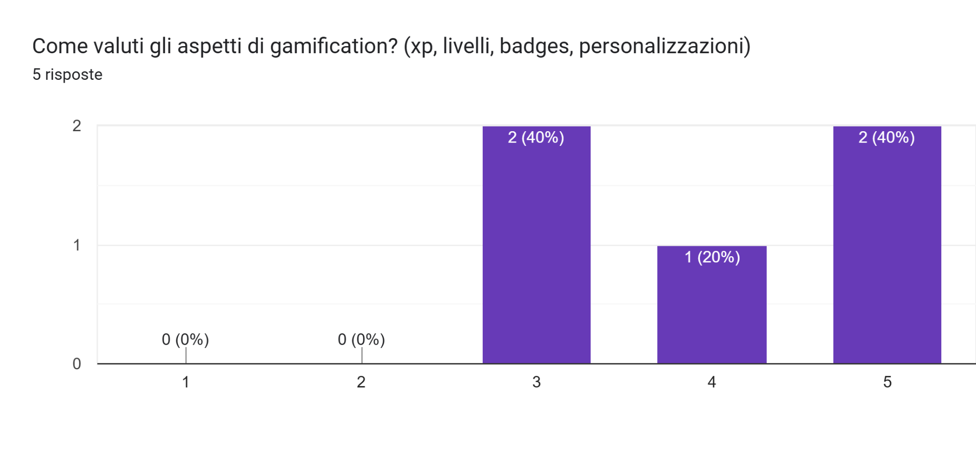
How do you rate the progression of the game? (how much is the xp earn rate fit, and how much is the level increase fast)
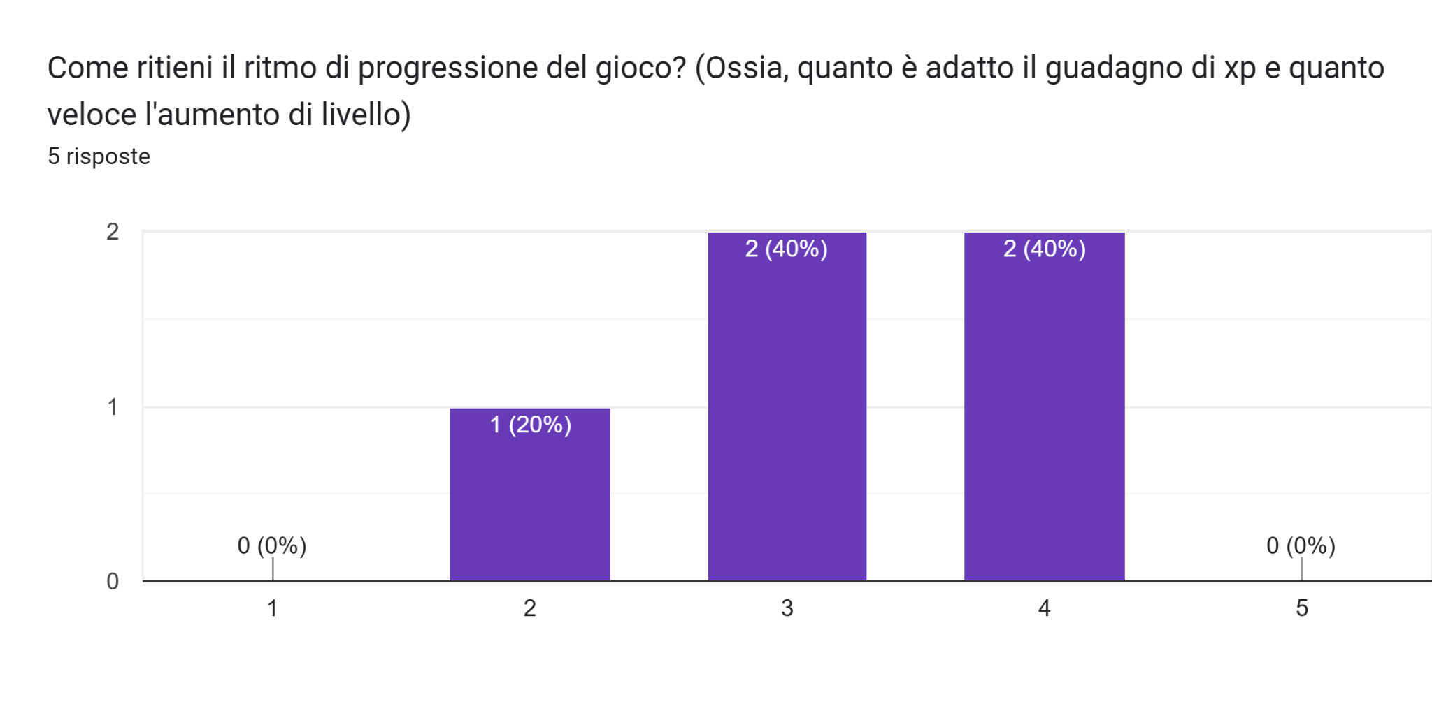

How do you rate the feedback after a quiz answer?
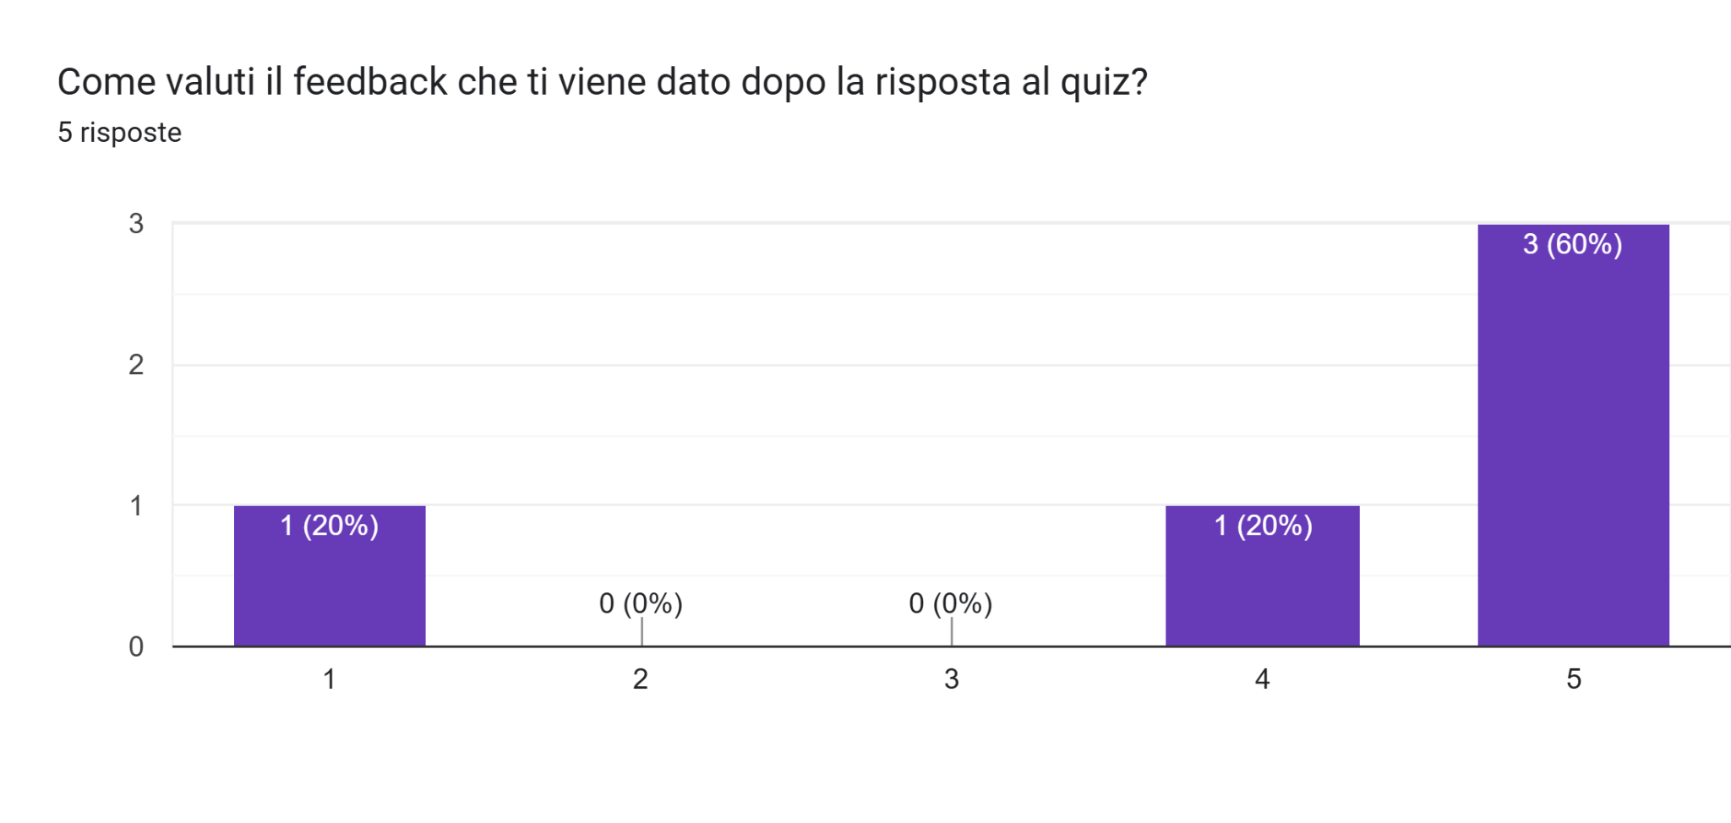
How interesting do you consider the different categories?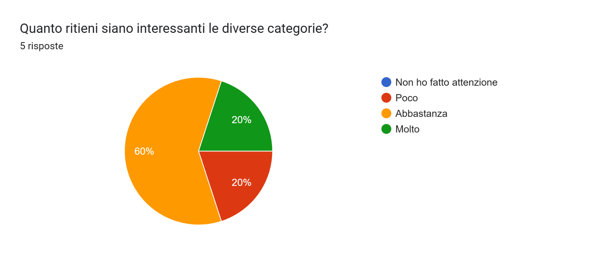How much do you believe would the various sections be useful?
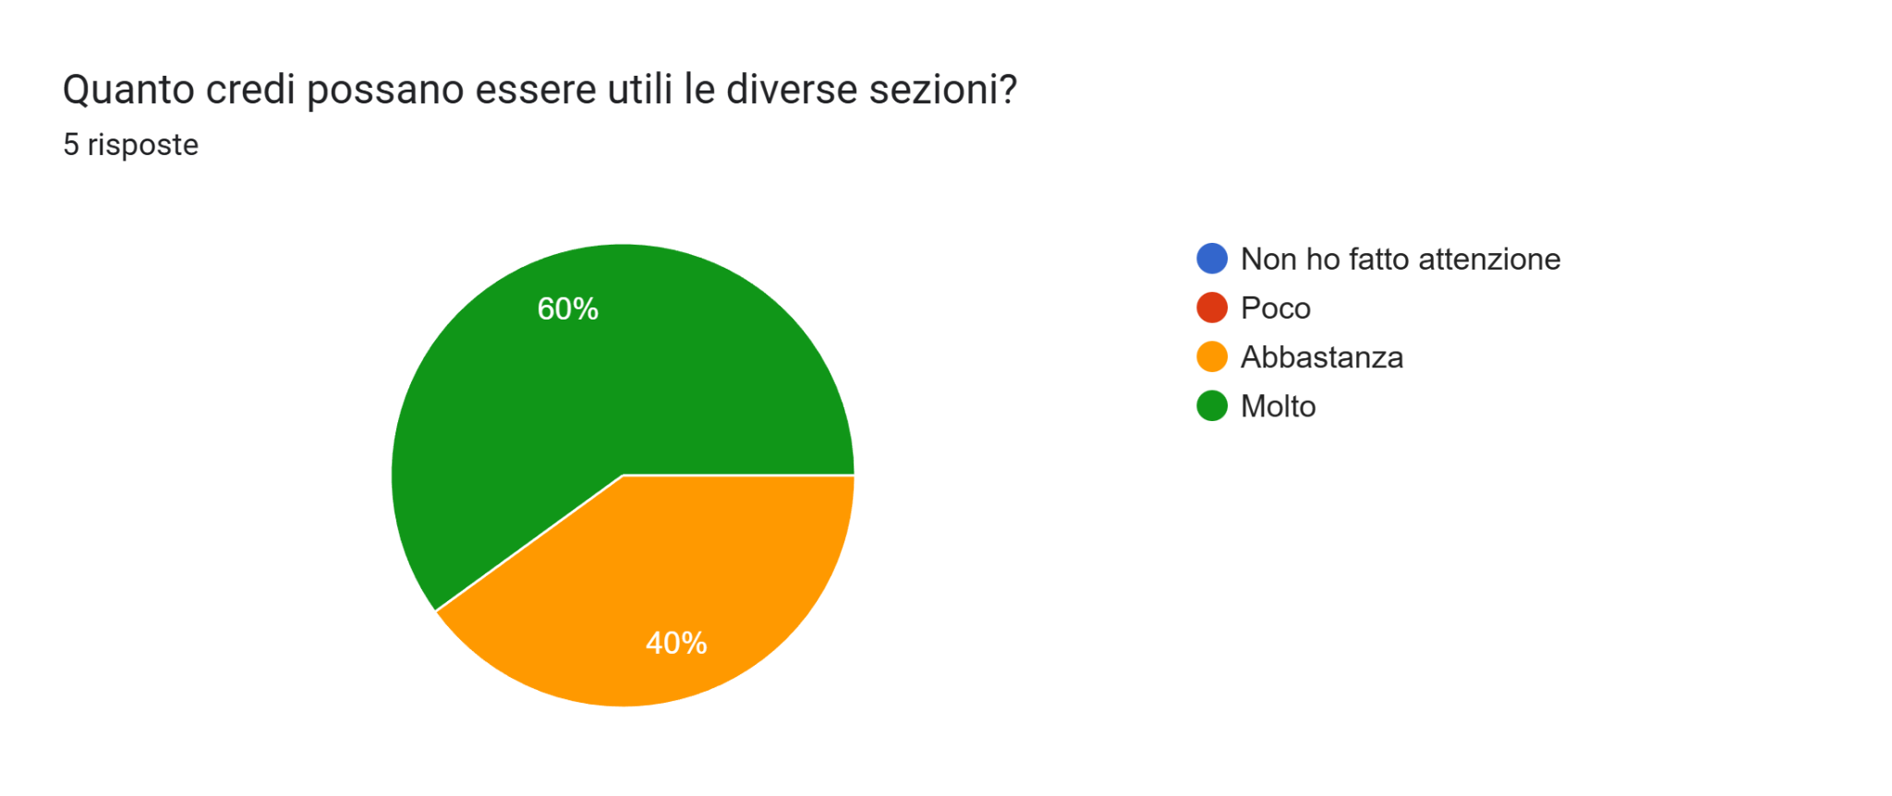

Which of these aspects bothered you the most? (open question with also pre defined options)
- UI Home: Add Correct Answers History. Add Levels Menu (Bar with level 2 = reward 1, level 2.5 = reward 2, etc.) UI MAP: Add Start Exploring button at the top of the map. UI PROFILE: Add Unlocked Badges Menu, Add Visited Places Menu with dates.
- You have to have XP and levels to unlock badges and profile photos, you have to keep following the application to ‘discover’ points.
- Having to answer the quizzes
- Must have XP and levels to unlock badges and profile photos
- I didn't immediately understand how to do the quiz.

What did you like most about the app? (open question with also pre defined options)
- Badges, points systems and similar
- The idea in general
- The general idea, map management and the idea of exploration
- Quizzes for learning, general educational purpose, map management and the idea of exploration, competing with other players to be first in the leaderboard
- Badges, points systems and similar features, Map management and the idea of exploration, The ability to keep me using the app, Competing with other players to be first on the leaderboard

In the current state of the application, how much would you be willing to use it in a trip of yours to a new city?
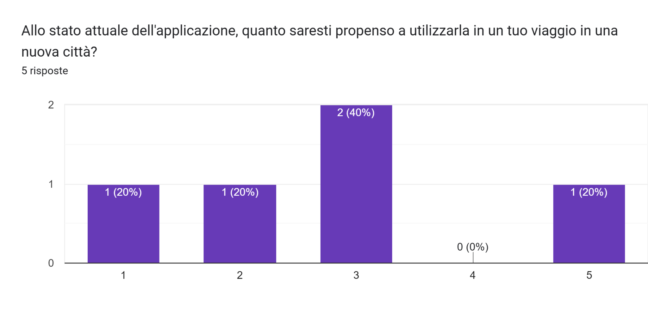
If we “fixed” the app implementing/removing aspects based on your feedback, how much would you be willing to use it in a trip of yours to a new city?
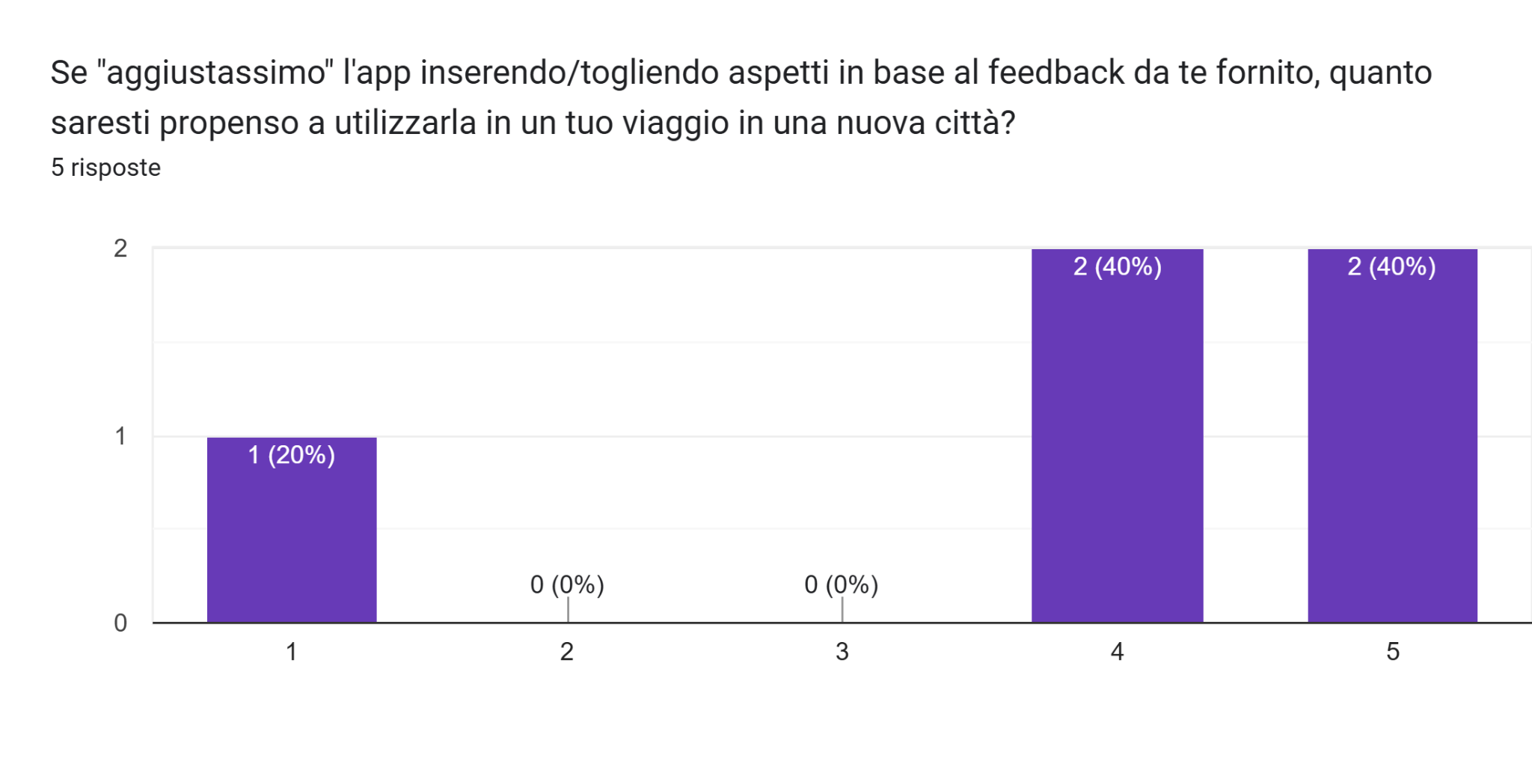

How do you value the general app experience
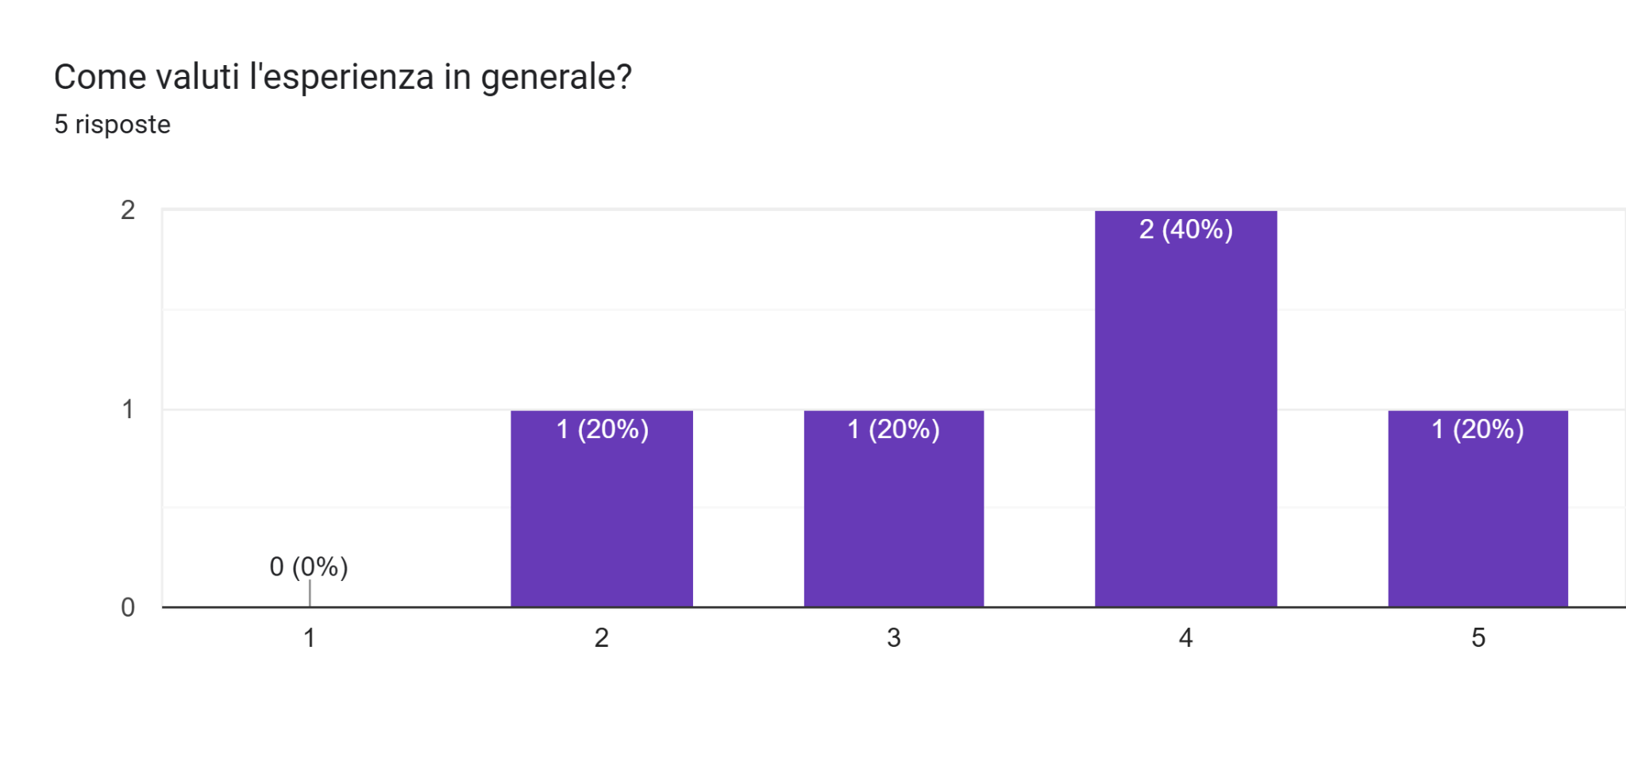

Now questions about future implementations

A group collaborative modality
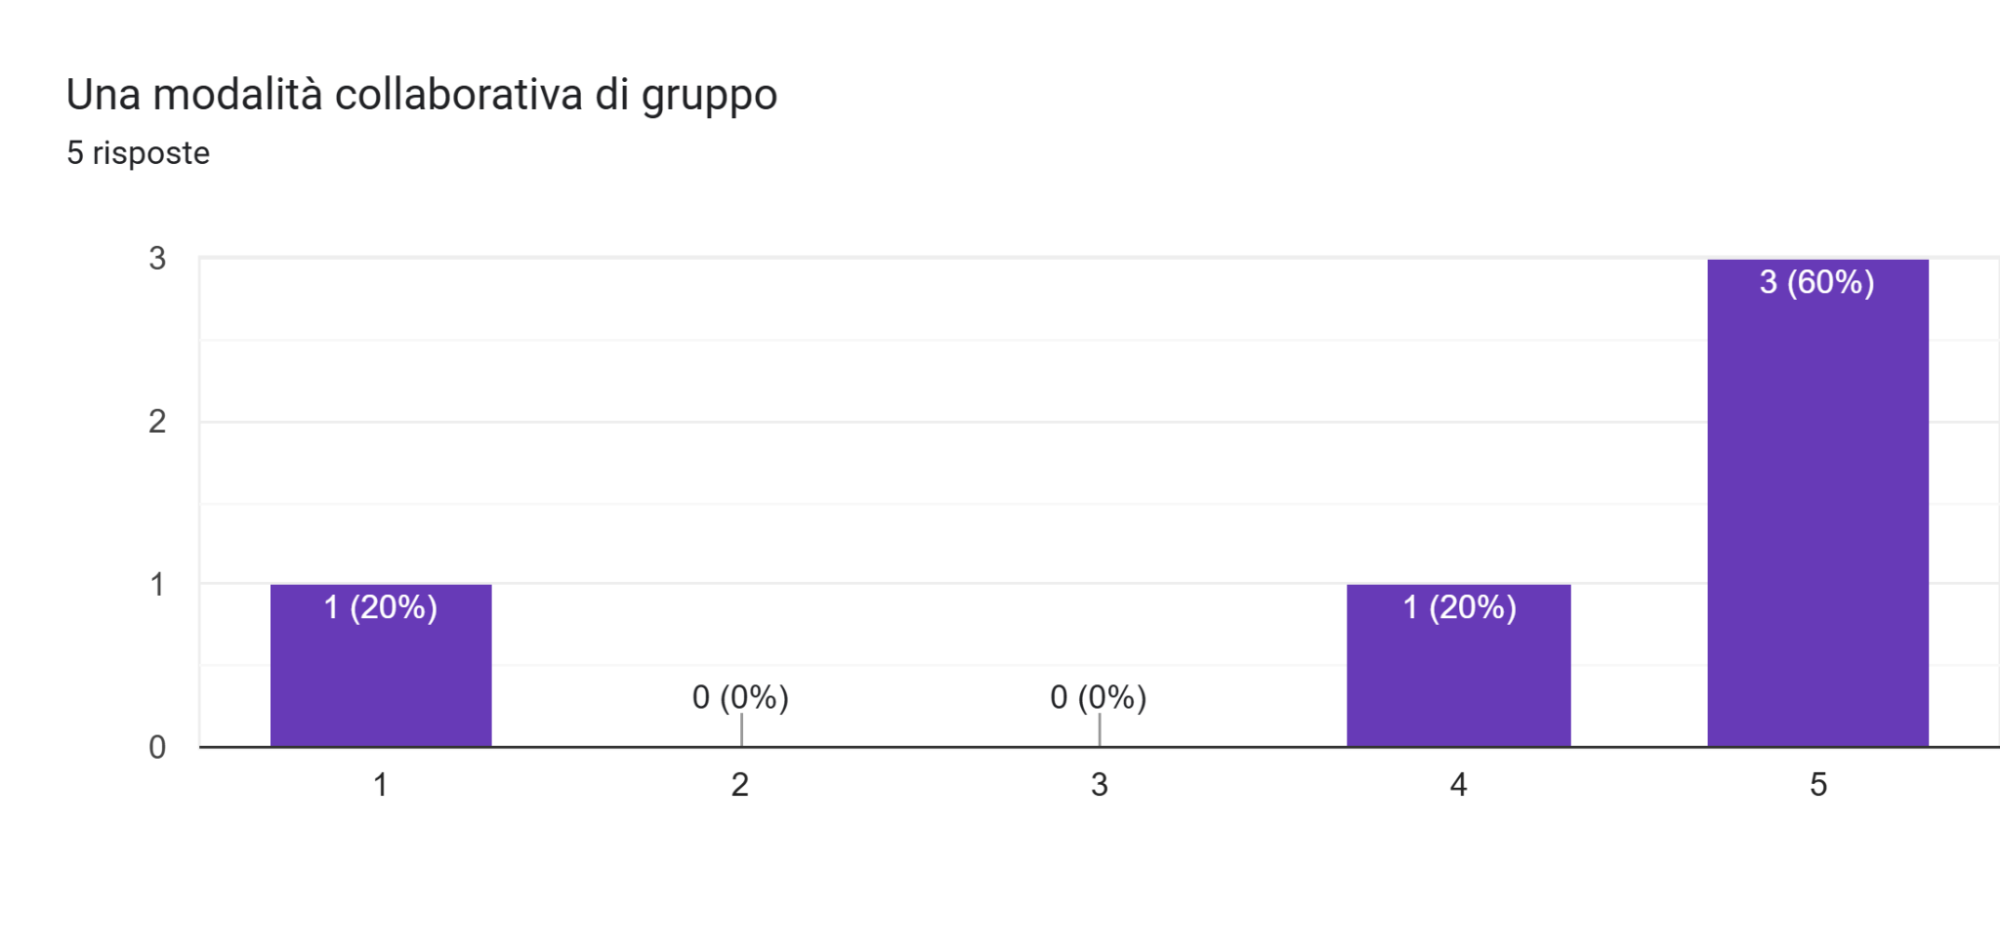

Probability to have secondary missions
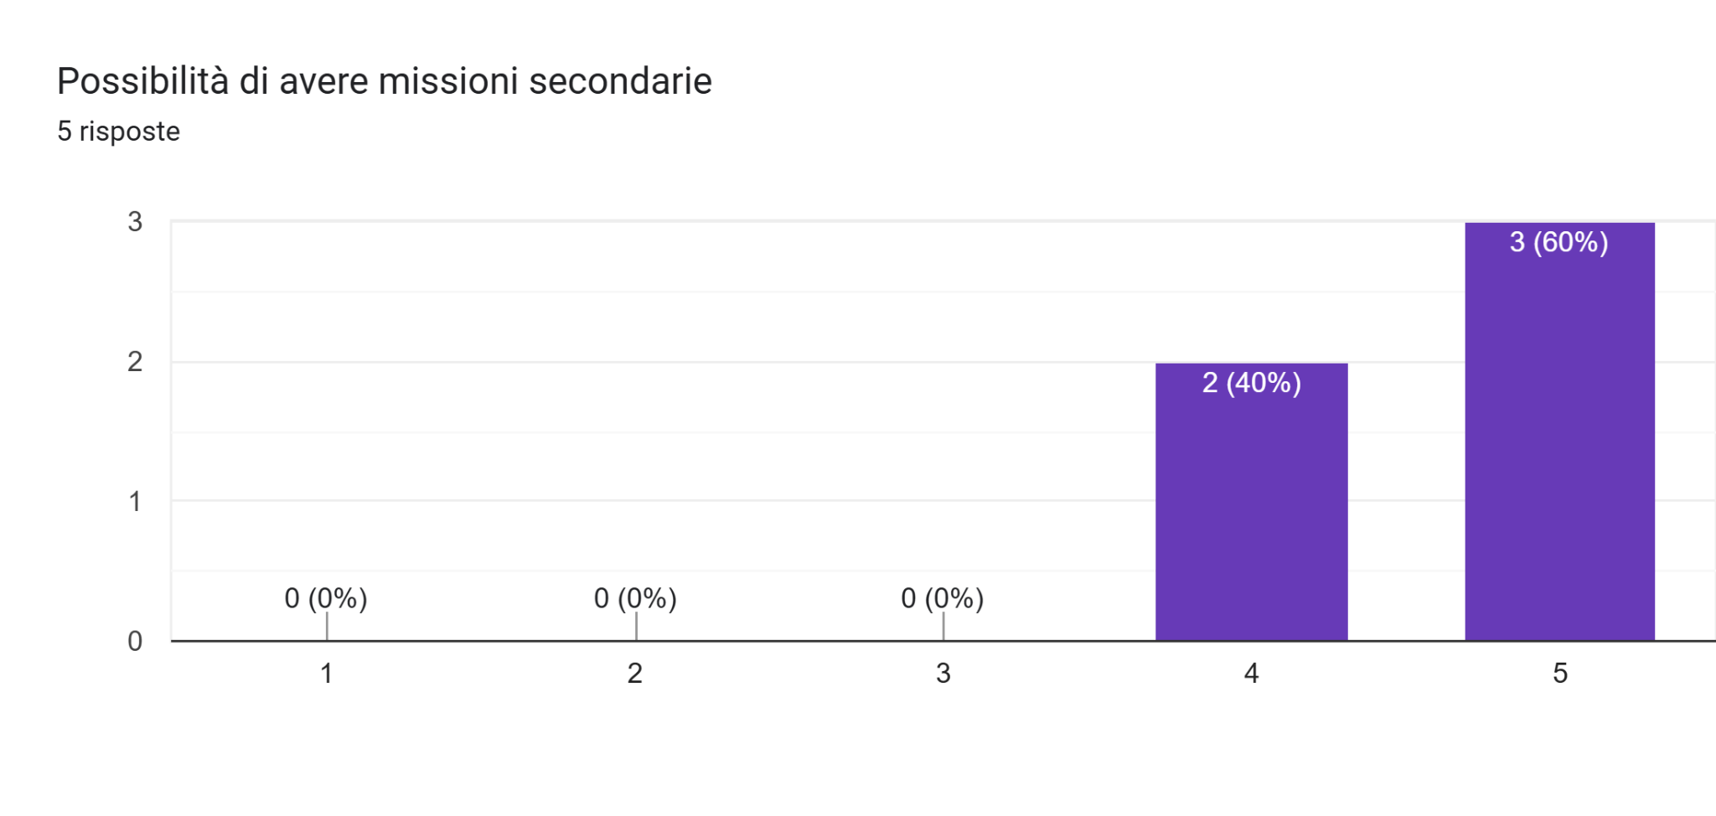
Greater customisation of the application and profile as a reward for achieving certain objectives

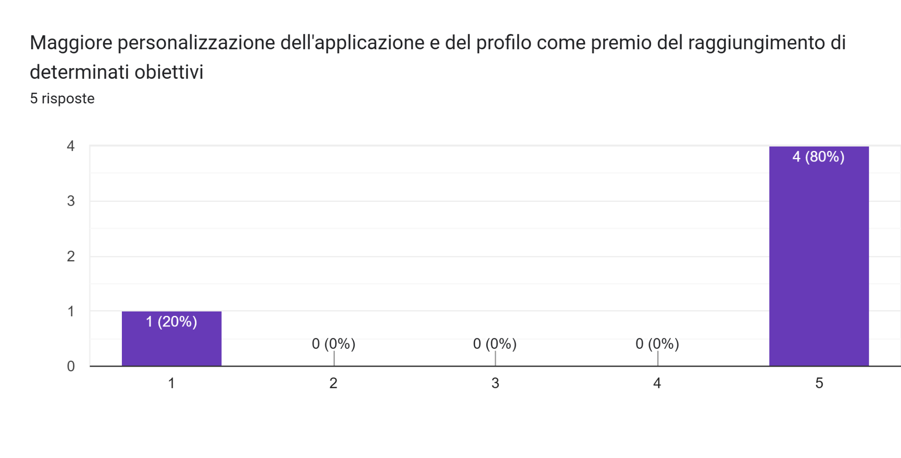
Add other features you may like (open question)
- Monthly reset: in months when there is no holiday (e.g. May, June, etc.), add cosmetics (Champion/King icon) as a prize for first place in the leaderboard and gems for the remaining podium places. During holiday months, give the cosmetics a specific theme (Santa Claus).
- Honestly, I would prefer to have a list of points of interest that I can select and mark the latter as, let's say, the main destination. A bit like how it works in video games. I would also like a feature that takes me to all the points of interest I have selected in the shortest time possible and covering the least distance possible.
- Being able to generate an itinerary based on a certain theme
- Increasing daily rewards that users can receive for each consecutive day they log in. If they do not log in daily, their progress will be reset to zero and they will start again from the minimum reward.

Our observations and conclusions
Starting from the users’ expectations before using the application, their opinions were pretty much aligned with what we set out to develop at the beginning (generating itineraries, being engaging, POI descriptions, cosmetics, social aspect), giving us the confidence that the initially laid-out ideas were on-target, willingness of engaging with a point system further strengthens the previous point. Around 15-30 mins gives us insights on how the visits should be structured and the desire for dining areas recommendations is not to be ignored.

The responses to the post-use questionnaire are largely in line with what we had planned to develop and what was set out as future development.
The application engagement and intuitiveness are in a good shape, in addition, some critical issues emerged, such as the fact that it is not very clear that you have to click on the POI icon on the map to answer the quiz. We also noticed that a number of suggestions for improvements are in line with our ideas, such as the history of points visited, which was not included in the gamidoc but was discussed, albeit briefly, as was the possibility of holding limited-time events or resetting points every so often.
We also noticed comments that, when taken together, indicate a need for more modes, depending on the user's needs, which has already been included in the gamidoc but not implemented.
It also emerged that users would not, or are neutral about using the application in its current state, which is completely understandable and acceptable, but they expressed a willingness to use it if substantial updates and fixes are made based on their feedback. We also noticed enthusiasm for some of the implementations and modes we proposed, which had already been included in the gamidoc but not implemented.
As a second input, we analysed the three reviews from easyChair, and we noticed that it was repeatedly highlighted that the only point that could be jarring or make the app more difficult to use is the very intensive use of quizzes, which is the only way to earn XP and continue the experience within the app. This is the same problem that was found in the questionnaire we compiled.
That means that the gamification system was appreciated, along with suggestions to implement, which will improve both itself and the user’s engagement. The project overall is on the right track and no change in direction is needed.

